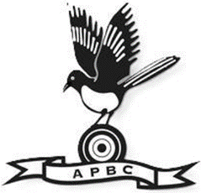
ALDISS PARK BOWLS CLUB MEMBERSHIP RENEWAL FORM

Name ………………………………………………………………………………………………………….
Address ……………………………………………………………………………………………………….
…………………………………………………………………………………………………………………….
Post Code …………………………………………………………………………………………………….
Phone Number ………………………………..…………. Mobile ……………………………………………………………………
e-mail address (please write clearly) ……………………………………………………………………………………………...
I apply for renewal/new membership of Aldiss Park Bowls Club in 2025. Please tick category.
Adult Membership £40
Junior Membership £20
Students in Full Time Education between 18 and 25 years £20
Social Membership £10

Please return this form to Sue Frost email apsecretary.sue@btinternet.com and arrange payment.
Payment: Cheques should be made payable to Aldiss Park Bowls Club or direct payment made using the following details. Aldiss Park Bowls Club, Sort Code 20-28-20, Account no. 63039846. Please use your name as the reference.
Data Protection:
I give permission for my telephone number(s) to be published in the Member Handbook YES/NO
I give permission for photos of me to be used by the County in their publicity material YES/NO
I give permission for my photo/name to be used by the Club on the website and FB page YES/NO
I give permission for my name/phone/email to be included in a password protected members area of the website YES/NO

Signed ………………………………………………………………… Date ………………………………………………….
League Choices If you wish to play in any of the leagues, please indicate your choices below.
League | Played | Choice | Help Out | Comments
Over 55s Age Concern -Woodpeckers & Jackdaws | Tues/Thur Afternoon (days vary).
Whissonsett | Mon Eve
Ladies-EBA Breckland | Mon Eve
Ashill | Tuesday Eve
Ladies’ Norwich 9s | Wed Morning
Men’s EBA | Wed Evening
North Elmham | Thurs Evening
Dereham and District | Friday Evening

